Related Work
Twitter is one of the most popular microblogging services in the world. Half billion tweets are generating every day by its users [1]. Messages posted on Twitter have been reporting everything from daily life stories to the latest local and global news and events. Monitoring and analysing this rich and continuous user‐generated content can yield to valuable information, allowing users and organizations to obtain actionable knowledge. This information can be accessible via Twitter’s public APIs. In order to do so, scientists proposed many different techniques for event-detection approaches that monitored Twitter’s events. Monitoring a set of messages in a specific period of time that are overlapped in vocabulary might lead to a common event. This titled as event stream.
large amount of meaningless messages and polluted content, can be obtain during Twitter stream, which negatively affect the detection performance. To overcome this challenge, instead of using the random sampled data in Twitter’s API, retrieving tweets can be matched by specific condition and concept of that event. This matter can be achieved by collecting some features from the event, like, special keywords, #hashtags, @mentions, and URL links. For example, Starbird and Palen collected information about the 2011 Egyptian uprising by using the keywords“egypt, #egypt, #jan25” , Nichols et al. collected sport related tweets using keywords “worldcup” and “wc2010” . However, the set of predeﬁned keywords is subjective and can easily lead to incomplete data but, the main drawback is, researchers need to know the event in advance. Laurissa, Xinyue, Stefan in [2] generalize the solution for different kind of event without any prior knowledge.
Burst Detection approaches are the most common practices used for Twitter sub-event detection. This is a way of identifying periods of time in which some event is unusually popular. In other words, it can be used to identify fads, or “bursts,” of events over time. To measure popularity, different statistical tactics might be tested. For example, Earle at el. compare the short-term-average of tweets volume to the long-term-average for identifying possible earthquakes, as well as the sport events and political affairs. In another example, ESA (The Emergency Situation Awareness) burst detector uses a binomial model B(p, N) to generate an expected distribution of feature occurrences in a given time window[3]. Some recent studies proposed using incremental clustering to solve the event evolution problem. Models are incrementally updated as new data arrives on a stream. Such methods may not be feasible to use for the Twitter due to the scale of updates. In [4] they achieve event detection with evolution tracking in real time through modelling events as cluster chains and addressing scaling concerns with new design choices. However, this system reached good result but they are relying on entity co-occurrence. Moreover, most of the sub-event detection algorithms are tailored to deal with particular type of events, like FIFA World Cup or Earthquake.

Sub-events detection by Real-time microblog monitoring (STRIM) framework

The simple framework for STRIM is to detect and summarises sub-events related to a special topic that is being investigated, such as sport events or virus pandemic. In [2] (this experimental research follows), the focus is to achieve higher accuracy on sub-event detection by increasing the coverage of the event content. By collecting, detecting and then extracting the most descriptive event-relevant tweets, the framework is focus on three steps; Adaptive crawler, Parallel Bursts detection, and Sub-event formulation component.

Adaptive crawler:
Before exploring this section, it is important to provide a definition for the key term tf–idf used in this area and subsequently in this experiment.
Def. TF-IDF: The number of times a word appears in a document, divided by the total number of words in that document(TF); the second term is the Inverse Document Frequency (IDF), computed as the logarithm of the number of the documents in the corpus divided by the number of documents where the specific term appears. TF-IDF is also a highly useful tool to filter out less important common words and can remove the requirement to manually maintain an extensive list of stop words (Stop-words are those words that appear very commonly across the documents, therefore losing their representativeness).
The adaptive crawler component collects a comprehensive set of event tweets by adaptively improving the Twitter search terms in real-time [2]. First of all, the keywords are manually defined according to the event of interest and remain unchanged for the entire collection period. The set of selected keywords with a query will be send to the Twitter’s stream API to select relevant tweets as a stream. The stream collected by this set of keywords is a baseline stream. In the next stage, the keyword adaptation parameter will identify event topic that arise in the midst of events and timely adjusts the search query to include these newly emerged keywords. From different keyword adaptation algorithm, Content Similarity Keyword Adaptation Algorithm (CS-KwAA) achieves the best performance in terms of achieving significant coverage with minimal noise [2]. This algorithm exploits the content similarity between different hashtags. For each word in primarily keywords, it will select high frequency hashtags that co-occurs with the word in a same time frame. The algorithm then, selects a set of most recent tweets for each selected hashtag. This collection of tweets will have converted into TF-IDF (Term Frequency — Inverse Document Frequency) vector. After that, it compares similarity of hashtag_based vector with keyword_based vector and will chose the hashtag with more similarity vector as a new keyword and will add it to primary keyword set. To measure the similarity, we can always define a threshold. Finally, a query that encodes all the new keywords and the initial keywords is sent to the Twitter API. This process repeats after every time frame. As a result, the output of this adaptive crawling model is the adaptive stream about event of interest and a set of extra keywords identified by the KwAA.

Parallel Bursts detection
Several methodologies have been studied for sub-event detection in Twitter. Unsupervised methods such as clustering aim to group similar tweets to detect speciﬁc sub-events (Pohl et al., 2012; Abhik and Toshniwal, 2013) and use simple representations such as tf-idf weighting combined with a similarity measure. Other unsupervised algorithms use topic modelling approaches, based on assumptions about the tweets’ generation process (Xing et al., 2016; Srijith et al., 2017). Several methods assume that a sub-event happens when there is a ‘burst’, i.e., a sudden increase in the rate of tweets on the considered event, with many people commenting on it. Recently, neural network methods have used more complicated representations (Wang and Zhang, 2017; Chen et al., 2018). Another unsupervised technique is anomaly detection that has been used in [2]. The algorithm known as burst detection, is designed to identify the sub-events by capturing the sudden bursts of tweets feature. The burst detection algorithm used by Twitinfo system is being consider in primary and adaptive steams in parallel to improve the detection of potential sub_events. The performance of this algorithm has been improved by using a smoothing technique. Precisely, the algorithm exploits the exponentially weighted moving average (EWMA) in TCP congestion control to identify the relatively maxima, i.e. burst, by considering the recent history. Moreover, applying the algorithm in both adaptive stream and extra-only stream increases the effectiveness to reduce the noise from the original stream in the sub-event detection. As a result, for any of the decomposed streams, a list of peak windows (a pair of timestamps, start and end of the detected event) is generated and sent to the next step.

Sub-event formulation
As mentioned before, the output from the parallel burst detection algorithm is a list of tuple (WLBL, WLAD and WLEX), that don’t provide the context of selected tweets (BL, AD, and Ex represent baseline, adaptive and extra streams respectively.). They only represent the timestamp where the local maximum point of tweets volume happened. As the number of tweets for any window might be very large therefore in each window the tweets that signifies it most have been selected. This matter has been done in two steps that clarified below.
Window harmonisation
Each selected window from the parallel streams contain tuple W= {ts, te, T}, that represent start(ts) and end (te)time of the selected window and a set of tweets (T). The process of selecting the most frequent unigram is based on TF-IDF value.
First, TF value is calculated by all the tweets in window W although, IDF is measured based on the tweets in all the previous identified peak windows.
Second, from each window, terms with highest TF-IDF value are selected to represent the corresponding potential sub-event. The number of summary terms allocated to be 5.
Third, combine duplication windows (windows that contain more than half common summery terms and also overlap in timespans) as a single window. New timespan for the combined window is the union of the individual timespan of all duplicated windows, while the summary terms are recalculated based on the same strategy for the summary selection process which is used in the Twitinfo system.
Summary tweets
Prior to calculation, all the tweets are pre-processed with stop, punctuation removal, stemming and twitter symbols (@ user mention and shorten URL) filtering, where the remaining terms are referred as informative terms. To do event summarization, TF-IDF value of a tweet has been considered, which is a very popular method. In this approach, the score of a tweet is the average TF_IDF value of the terms appear. As the tweets have different sizes, normalization has been used to avoid the bias. Precisely, the summary tweets have the highest normalized TF-IDF score among all the tweets belonging to that peak window and have at least two terms as a longer tweet with the same normalized TF-IDF score is more informatics.
Community Detection
Community detection in a social network is categorising sets of nodes in such a way that the connections of nodes within a set are more than their connection to other network nodes.
There are wide range of definition between researchers from different area to quantify a measurement for community. This rise from different goals for what it is about the network that we want to understand, and lead to different perspectives on how to formulate the problem of community detection. Girvan and Newman proposed a method which adopted "betweenness centrality" to ﬁnd community boundaries. Then, they present "modularity" to evaluate the overall quality of a network partition. It inspires researchers to design an objective function to detect communities hidden in networks. Since the objective is often hard to optimize exactly, approximation algorithms can be employed to ﬁnd sets of nodes which could be considered as communities. According to the technical principles that they used, the existing representative methods could be divided into ﬁve categories:
1-Hierarchical clustering method. 2-Modularity optimization method. 3-Label propagation method. 4-Information ﬂow method. 5-Matrix decomposition method [5]. In this approach greedy modularity method has been used that provides strong cohesiveness of groups with high internal density [6].

Sentiment Analysis
There are two main families of sentiment analysis techniques, machine learning and semantic orientation. Machine learning sentiment analysis techniques use standard machine learning methods; a classification model is trained to distinguish between the different sentiment classes. Semantic orientation techniques involve creating a dictionary of subjectively meaningful words, and in some cases word modifiers, and using this dictionary to score a document’s subjective content. Using such techniques enables much faster sentiment analysis, and makes it possible to perform sentiment studies on such large data sources as Twitter [7].

Random Network
Many scholars from different topics have been exploring a wide variety of methods and algorithms to achieve an accurate and effective tools in order to compare real networks. On the other hand, many random graph models are known reflecting the diverse types of complex networks encountered in different areas. Most of the time, a random graph might be described by a probability distribution or a random process which generates them. Precisely, it can be obtained by a set of n distinct vertices and using probability to create edges between them. We will then study the stages that this probability differs. In 1950s one of the model was born in graph theory and known as random graph by Paul Erdös and Alfréd Rényi. The Erdös-Rényi’s random graph model has several attractive properties and it is exceptionally quantifiable; but connectivity of time varying graphs is profoundly distinct with that of static graphs. Indeed, this model allows easy calculations for graph dynamics quantifications. Hens, this theory offers an intelligible practical framework for illustrating social behaviours that vary over time. These variations may be due either to behavior transmutations or to mobility of entities (and relationships). In the Erd˝os–R´enyi random graph, every vertex plays the same role, leading to a completely homogeneous random graph. Of course, vertices do have diﬀerent degrees, but the amount of variability in degrees in the Erd˝os–R´enyi random graph is much smaller than in many real-world applications [8].
Generating Random Networks
In order to compare the sochi network to the Erdos Renyi(ER), we present a short review of several of the most used approaches to network comparison in the table below. Average has been considered for the three ERs models. Numbers has been rounded up to 6d.p. Sochi_AD(node=1474, edges=1970). ER (node=1474, edges=1973, p=0.001856)
 | Average Degree | Clustering Coefficient | Page Rank | Network Density | No.Connected Component | Size Largest Component
Sochi_AD | 2.6730 | 0.037943 | 0.000678 | 0.001815 | 103 | 1237
Erdos Renyi | 2.6775 | 0.001375 | 0.000678 | 0.001817 | 119 | 1339.67
First graphs represent the distribution of node’s degree in two graphs. The ER model-based random network graphs are characteristic of having a low variation in node degrees, and hence do not match closely to graphs abstracting real-world networks.
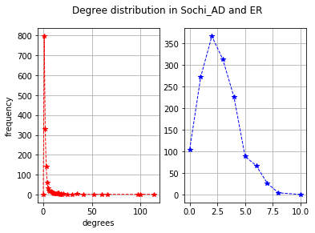
Average Clustering Coefficient, another major difference is in clustering coefficients values. The clustering coefﬁcient reﬂects the tendency that neighbours of a node are also neighbours to each other (Rubinov & Sporns, 2010). In this experiment, nodes with lowest degree has been removed progressively from the graphs and ave.clustring coefficient is observed. ERs, are constantly decreasing until it reaches zero while there are almost 200 nodes available however this changes for real graph is fluctuated.
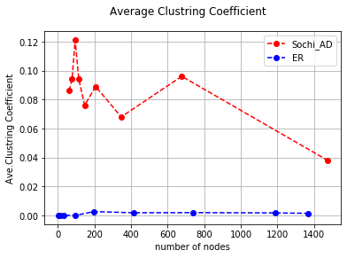
Size of Largest component and number of connected components are two other comparison approaches here. In the first removal (nodes with zero degree), AD has 103 different components and 1237 as a size of largest component, this is 15 and 1340 in ERs in which this represents very different networks at start. By removing nodes with degree one, AD lost more than half of its nodes while ERs stay connected with 8 different subgroups in which most of them belong to one giant one. Eventually, when we only had one node in ER, in AD, 60 nodes were strongly connected. Two graphs below are demonstrating the differences.

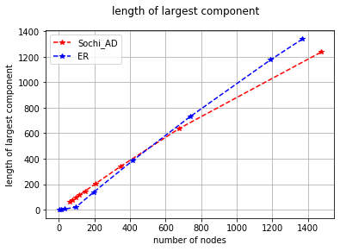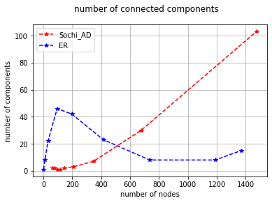

[1]. Shih-Feng Yang and Julia Taylor Rayz. An Event Detection Approach Based On Twitter Hashtags. April, 2018
[2]. Laurissa Tokarchuk, Xinyue Wang, Stefan Poslad2. Piecing together the puzzle: Improving event content coverage for real-time sub-event detection using adaptive microblog crawling. Nov, 2017.
[3]. Bella Robinson, Robert Power, Mark Cameron. A Sensitive Twitter Earthquake Detector.
[4]. Mateusz Fedorysza, Brent Frederick, Vijay Rajaram, Changtao Zhong. Real-time Event Detection on Social Data Streams. July, 2019
[5]. Zhongying Zhaoa,b, Shaoqiang Zhenga, Chao Lia, Jinqing Suna, Liang Changc, Francisco Chiclana. A Comparative Study on Community Detection Methods in Complex Networks.
[6]. Martin Rosvall, Jean-Charles Delvenne, Michael T. Schaub, and Renaud Lambiotte. Different approaches to community detection.Dec, 2017
[7]. William Deitrick, Benjamin Valyou, Wes Jones, Joshua Timian, Wei Hu. Enhancing Sentiment Analysis on Twitter Using Community Detection. June, 2013
[8]. Remco van der Hofstad. Random Graphs and Complex Networks. 2014

